Order Of Service

Singing: Psalm 18—CW page 69

Reading: Psalm 69:19-36

Opening Hymn: CW 260

Reading: Acts 9:1-9

Request Hymn: CW Supplement 754

Reading: John 18:19-27

Sermon Hymn: CW 363

Sermon Text: Daniel 4:28-33

The Storm Strikes

Prayer

The Apostles’ Creed, TLH page 12

Holy Communion

The Lord's Prayer

The Blessing

Closing Hymn: CW 496

* * * * * * * * * * *

Bible Study: Lambs: Rain
Sheep: Romans 10:10-16
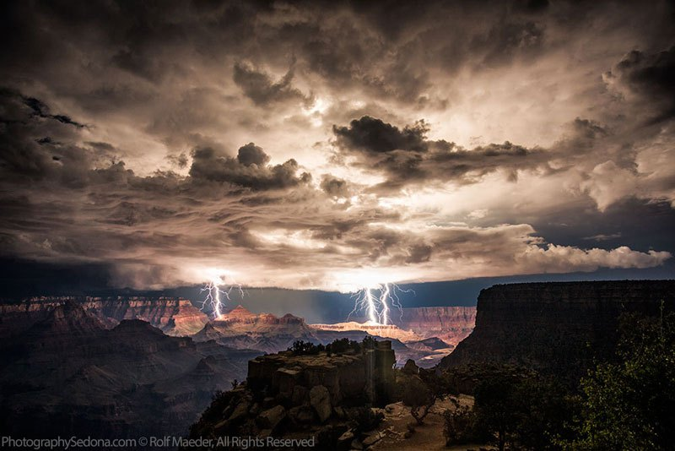
The Storm Strikes

Water
Of
Life
8 April 2018

W A T E R O F L I F E

Independent Christian Church—Conservative Lutheran Doctrine

Worship Service: 9:30 a.m. Bible Study: 10:45 a.m.

Larry Cooper, Pastor E-Mail address:
111 N. Ridge Road lcooper@wateroflife.cc
Coon Valley, WI 54623 Web Site:
Phone: (608) 452-2105 www.wateroflife.cc

* * * * * * * * * * * * * * * * * * * * * * * * * * *

Sermon Text: Daniel 4:28-33

The Storm Strikes

* * * * * * * * * * * * * * * * * * * * * * * * * * *

Daniel 4:28 All this came upon the king Nebuchadnezzar.
:29 At the end of twelve months he walked in the palace of the kingdom of Babylon.
:30 The king spake, and said, Is not this great Babylon, that I have built for the house of the kingdom by the might of my power, and for the honour of my majesty?
:31 While the word was in the king's mouth, there fell a voice from heaven, saying, O king Nebuchadnezzar, to thee it is spoken; The kingdom is departed from thee.
:32 And they shall drive thee from men, and thy dwelling shall be with the beasts of the field: they shall make thee to eat grass as oxen, and seven times shall pass over thee, until thou know that the most High ruleth in the kingdom of men, and giveth it to whomsoever he will.
:33 The same hour was the thing fulfilled upon Nebuchadnezzar: and he was driven from men, and did eat grass as oxen, and his body was wet with the dew of heaven, till his hairs were grown like eagles' feathers, and his nails like birds' claws.

The Storm Strikes

“While the word was in the king’s mouth . . . . . ”

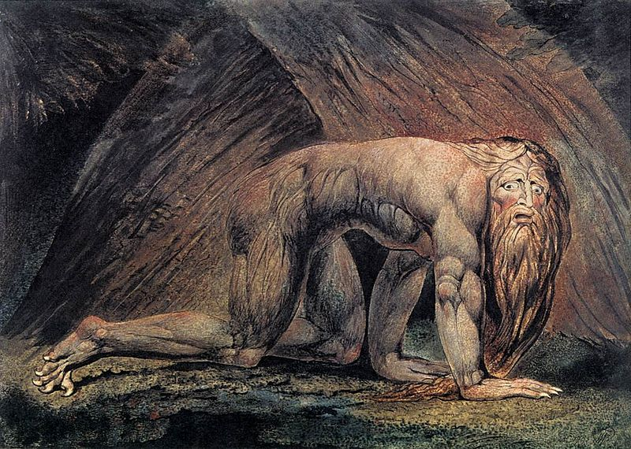

“The kingdom is departed from thee!”

